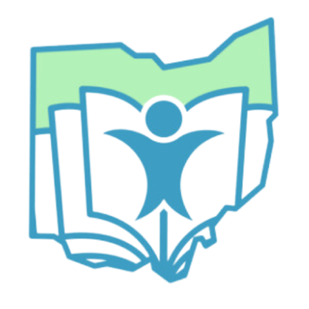

Family University Conference

Serving families with children who are Deaf/Hard of Hearing, Blind, Visually Impaired or Deafblind
Learn from role models in the community, accessibility at home and in the community and technology! This session will also offer hands on opportunities to explore low tech and high-tech materials to support success for learners. Each family will receive a Family Empowerment Kit.

Date: May 11, 2024
Time: 12:00 pm to 4:00 pm
Location:
Ohio State School for the Blind
5220 North High Street
Columbus, Ohio 43214

Registration is free. Register here:
https://docs.google.com/forms/d/e/1FAIpQLSfGVaTZfuOGKaAMNAzPRU9hNkhOx4V6Dx2VAPSQix_yt6yWMQ/viewform
Students interested in the presentation are encouraged to attend with their family! *Please be mindful that separate childcare is not available, and Lunch is on your own.

This event is brought to you by Statewide Services & Outreach at the Ohio Deaf and Blind Education Services, The Outreach Center for Deafness and Blindness and The Ohio Center for Deafblind Education.
